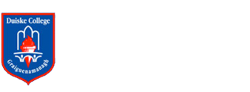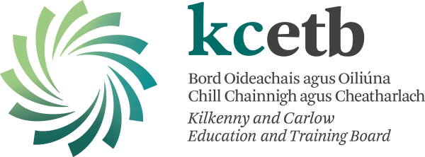

**AGREED REPORT**

**Duiske College Board of Management 12/1/23**

* The Board thanks and commends the two staff presenters on the evening – Teresa Doyle DEIS coordinator and Will O Shea HSCL. Both presentations greatly added to the overall knowledge of the work carried out here in Duiske College in these areas.
* The Board congratulates Marie Hayles on her recent AP2 appointment and extends best wishes to Louise Doyle as she embarks on Maternity Leave.
* The Board was delighted to see the return of the Christmas Carol service. The amount of ongoing extra and co-curricular activities was noted and the board thanks all relevant teachers for their efforts.
* The board welcomed the return of in-person Parent Guardian Teacher meetings.
* The Board has ratified and reviewed the statutory change to the school’s Admissions statement.
* Congratulations to current pupil Sean Hamilton and past pupils, Pierce Blanchfield and Ted Dunne on their recent presentation of Leinster and All Ireland u17 and u20 medals.
* Our next meeting will be on March 7th in a room in the new replacement prefab.