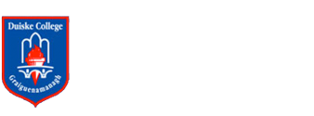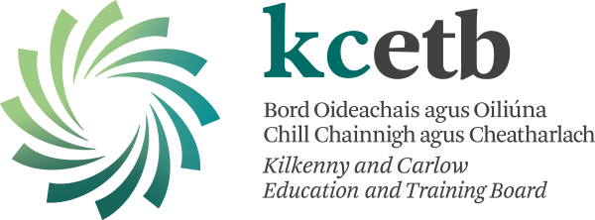

AGREED REPORT

Board of Management meeting

5/12/2022

* Sincere best wishes are extended to John Maddock on his retirement form a distinguished service here in Duiske College.
* The Board welcomes the sanctioning of an ASD Special class for Duiske College.
* The Board welcomes the recent report carried out on the ‘Conditions of the Buildings’ and looks forward to viewing the rep.
* The Board congratulates the Parent’s Association on their Monster Draw and efforts thus far this year.
* The Board congratulates all those, students and staff, on the recent Junior Cycle results.
* The Board is delighted with the progress being made on the works replacing the Music prefab.
* The Board wishes to thank all the staff of Duiske College for their work and wishes them all the best for the coming Christmas season.
* Next board meeting is scheduled for January 23rd 2023.