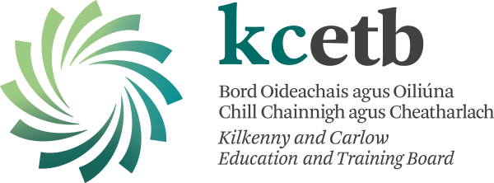

AGREED REPORT
Duiske College Board of Management 12/9/22

- The board wishes to congratulate the Leaving Certificate students of 2022, and their families on their results. The Board also thanks the school staff for their work over the last year.
- The Board has passed and reviewed a number of statutory documents including, Child Safeguarding Statement, Anti-Bullying Policy and Anti-Bullying Checklist.
- The Board would like to send best wishes to all Junior Cycle 2022 students as they await their results.
- The board wishes to thank Olivia Staunton for her input to the Board of Management of Duiske College for the last number of years.
- The Board congratulates Sean O Neill, who was selected as the Duiske College Student of the Year 2022.
- The Board congratulates Patrick McCormack on his stunning performances at the recent SUP World Championships in Poland.

